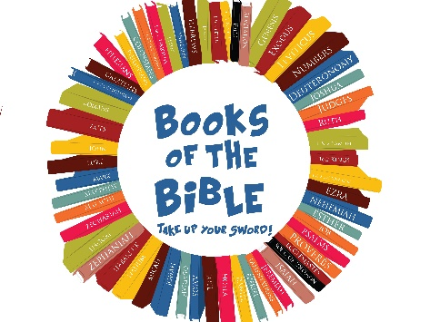
Week | Date | KC and GIG
Week 1 | Sept 29 | Lesson 1  Take Up Your Sword
Week 2 | Oct 6
Week 3 | Oct 13 | Lesson 2
Week 4 | Oct 20 | Lesson 3  Lesson 3
Week 5 | Oct 27 | Lesson 4  Lesson 4
Week 6 | Nov 3
Week 7 | Nov 10 | Lesson 5  Lesson 5
Week 8 | Nov 17 | Lesson 6  Lesson 6
Week 9 | Nov 24 | Lesson 7  Lesson 7
Week 10 | Dec 1
Week 11 | Dec 8 | Lesson 8  Lesson 8
Week 12& 13  TGP  (Christmas Story) | Dec 15 | Unit 17 Session 1  Unit 17 Session 1
 | Dec22 | Unit 17 Session 2  Unit 17 Session 2
Week 14 | Dec 29 | LKC, KC and GIG combined
Week 15 | Jan 5
Week 16 | Jan 12 | Lesson 9  Lesson 9
Week 17 | Jan 19 | Lesson 10  Lesson 10
Week 18 | Jan 26 | Lesson 11  Lesson 11
Week 19 | Feb 2 | Lesson 12 | Lesson 12

